EXPERIMENT NO 5

5B

Aim: Execute the following scripts.

5.b.1

Script to perform arithmetic operations

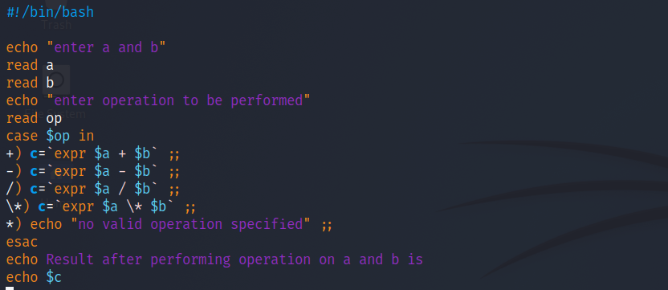

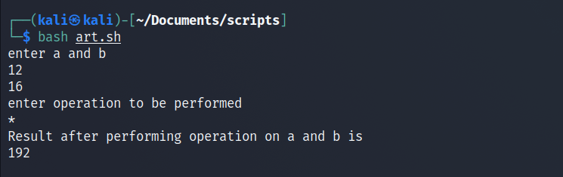

5.b.2

Script to calculate simple interest

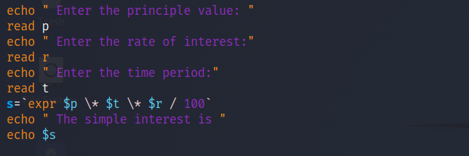

Fig 5.b.2

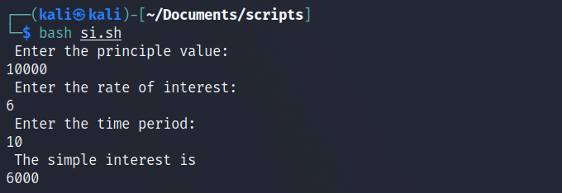

Fig 5.b.2.1

5.b.3

Shell script to find largest number among three numbers

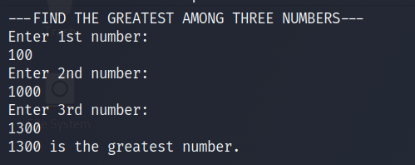

Fig 5.b.3

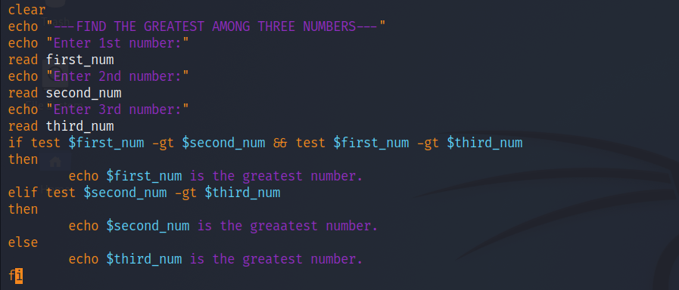

Fig 5.b.3.1

5.b.4

Shell script to know if the given year is leap year

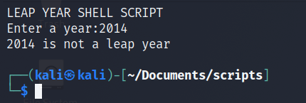

Fig 5.b.4

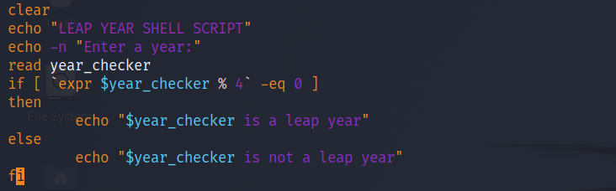

Fig 5.b.4.1

5.b.5

Script to print multiplication table using while loop

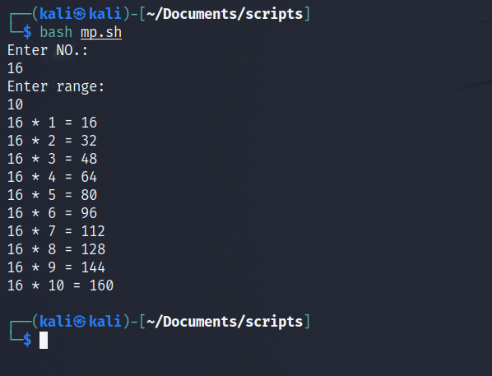

Fig 5.b.5

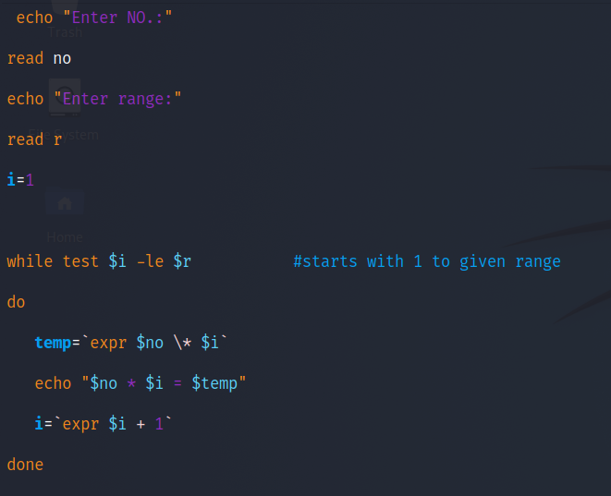

Fig 5.b.5.1

5.b.6

Write a script to compare two strings

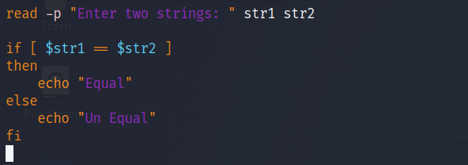

Fig 5.b.6

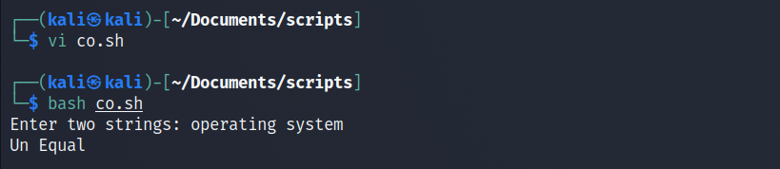

Fig 5.b.6.1

5.b.7

Shell script to make a menu driven calculator

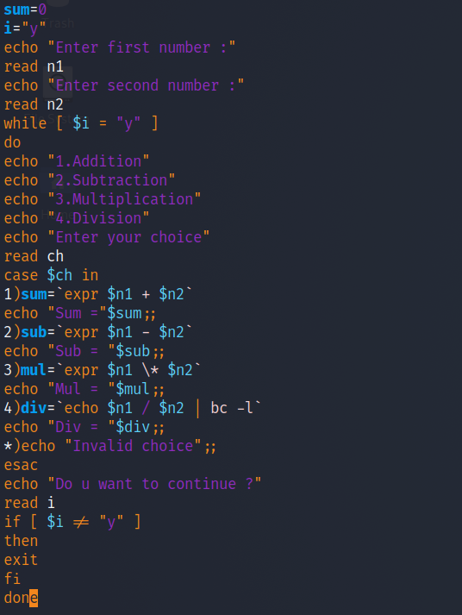

Fig 5.b.7

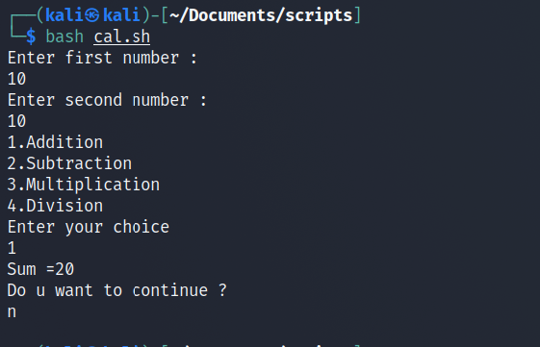

5b.8

Shell script to display pattern \*\*\*\*\*\*



Fig 5b.8.

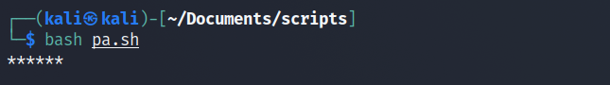

Fig 5b.8.1

Conculsion :

In the above experiment we performed a number of scripts in which we carried

Out taking input from the user doing calculation on it making a menu driven calculator t perform calculation printing patterns and many simple tasks.